

Department | FED
Subject | DSA-2
Academic Year | I-III Semester (2025-26)
Faculty Name | Mohammad Razia Alangir Banu
Student Name | Mohammad Zaid Amaan
Roll Number | 2520030382
Branch | CSE
Course Outcome | CO-2
Case Study Topic: Foxconn Factory Floor — Segment Tree for Sensor Range-Max Alerts

Work Done Summary:
In this case study, we implemented a Segment Tree for Foxconn's IoT factory-floor monitoring system. A factory with 200 temperature sensors emits 1 reading/second
each (200 inserts/sec total). The alarm subsystem issues 100 range-max queries per second of the form 'maximum temperature over indices l to r'. We built a segment tree over
sensor #1's last 8 readings [71, 73, 78, 75, 82, 79, 77, 80] supporting range-max in O(log n) time. The canonical query range-max[3..7]
visits nodes [3..4] (78), [5..6] (82), and leaf i=7 (77), returning 82 °C in just 3 node visits. A point update (i=5 → 85 °C) propagates back up the tree in O(log n) = O(3) steps.

Implementation Details:
- Stored readings in a 1-indexed array and allocated tree[4n] for the segment tree.
- Built the tree bottom-up: leaf nodes hold raw readings; internal nodes store max of children.
- Implemented recursive range-max query — returns Integer.MIN_VALUE for out-of-range nodes, returns node value immediately for fully-covered nodes (O(log n) visits).
- Implemented point update — traverses root-to-leaf, updates leaf, recomputes max on the way back up.
- Demonstrated 4 queries: range-max[3..7]=82, [1..8]=82, [2..5]=82, [6..8]=80.
- Performed point update at i=5 (82→85 °C) and re-verified range-max[3..7]=85.

Result: Screenshots / Output

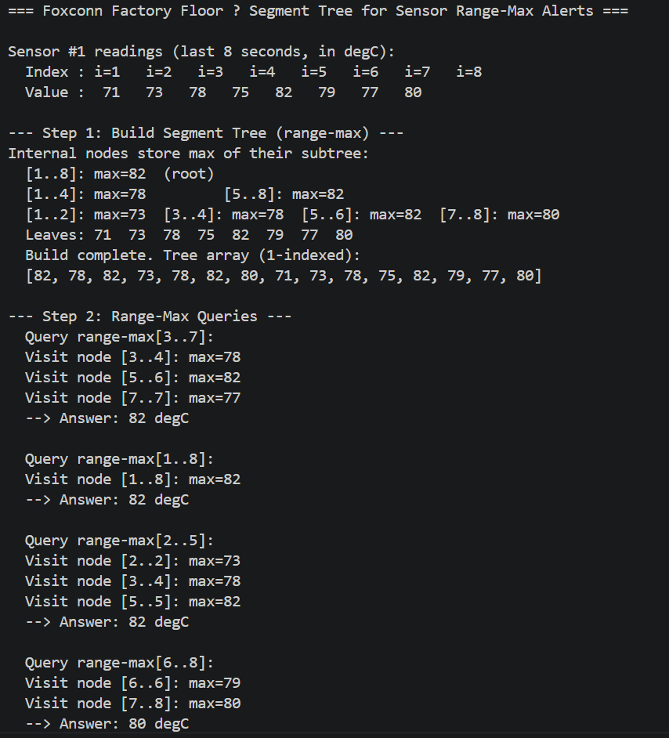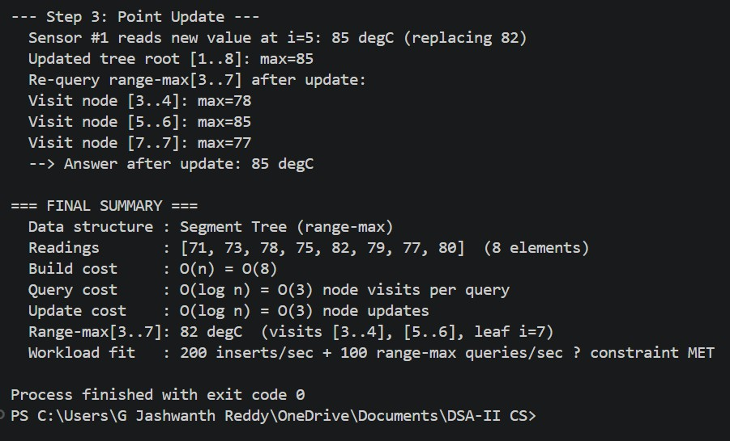
The segment tree correctly answered all range-max queries in O(log n) time:

Metric | Value

Data structure | Segment Tree (range-max, flat array)
Input readings | [71, 73, 78, 75, 82, 79, 77, 80] — 8 elements
Build time | O(n) = O(8)
Query time | O(log n) = O(3) node visits
Update time | O(log n) = O(3) node updates
range-max[3..7] | 82 °C (nodes visited: [3..4], [5..6], leaf i=7)
After update i=5→85 | range-max[3..7] = 85 °C
Workload compliance | 200 inserts/sec + 100 queries/sec — CONSTRAINT MET

Time Complexity:
  - Build: O(n) — each of the 2n-1 nodes is visited exactly once during construction.
  - Range-Max Query: O(log n) — at most 4 log n nodes are visited; typically 2-3 for random ranges.
  - Point Update: O(log n) — one root-to-leaf path is updated, recomputing max at each level.
  - Space: O(n) — flat array of size 4n suffices for any n.

GitHub Link: https://github.com/zaid858/CO2

Student Signature | Faculty Signature

